**Travelling Salesman Problem-**

You are given-

* A set of some cities
* Distance between every pair of cities

Travelling Salesman Problem states-

* A salesman has to visit every city exactly once.
* He has to come back to the city from where he starts his journey.
* What is the shortest possible route that the salesman must follow to complete his tour?

**Example-**

The following graph shows a set of cities and distance between every pair of cities-

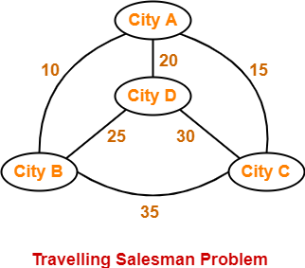

If salesman starting city is A, then a TSP tour in the graph is-

**A → B → D → C → A**

Cost of the tour

= 10 + 25 + 30 + 15

= **80 units**

**PRACTICE PROBLEM BASED ON TRAVELLING SALESMAN PROBLEM USING BRANCH AND BOUND APPROACH-**

**Problem-**

Solve Travelling Salesman Problem using Branch and Bound Algorithm in the following graph-

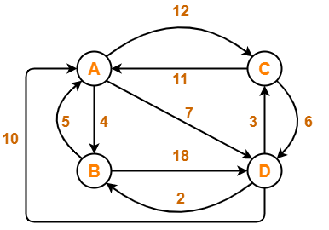

**Solution-**

**Step-01:**

Write the initial cost matrix and reduce it-

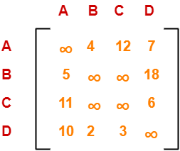

|  |
| --- |
| **Rules**   * To reduce a matrix, perform the row reduction and column reduction of the matrix separately. * A row or a column is said to be reduced if it contains at least one entry ‘0’ in it. |

**Row Reduction-**

Consider the rows of above matrix one by one.

If the row already contains an entry ‘0’, then-

* There is no need to reduce that row.

If the row does not contains an entry ‘0’, then-

* Reduce that particular row.
* Select the least value element from that row.
* Subtract that element from each element of that row.
* This will create an entry ‘0’ in that row, thus reducing that row.

Following this, we have-

* Reduce the elements of row-1 by 4.
* Reduce the elements of row-2 by 5.
* Reduce the elements of row-3 by 6.
* Reduce the elements of row-4 by 2.

Performing this, we obtain the following row-reduced matrix-

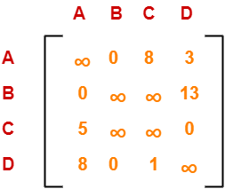

**Column Reduction-**

Consider the columns of above row-reduced matrix one by one.

If the column already contains an entry ‘0’, then-

* There is no need to reduce that column.

If the column does not contains an entry ‘0’, then-

* Reduce that particular column.
* Select the least value element from that column.
* Subtract that element from each element of that column.
* This will create an entry ‘0’ in that column, thus reducing that column.

Following this, we have-

* There is no need to reduce column-1.
* There is no need to reduce column-2.
* Reduce the elements of column-3 by 1.
* There is no need to reduce column-4.

Performing this, we obtain the following column-reduced matrix-

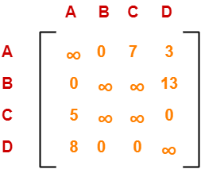

Finally, the initial distance matrix is completely reduced.

Now, we calculate the cost of node-1 by adding all the reduction elements.

Cost(1)

= Sum of all reduction elements

= 4 + 5 + 6 + 2 + 1

= 18

**Step-02:**

* We consider all other vertices one by one.
* We select the best vertex where we can land upon to minimize the tour cost.

**Choosing To Go To Vertex-B: Node-2 (Path A → B)**

* From the reduced matrix of step-01, M[A,B] = 0
* Set row-A and column-B to ∞
* Set M[B,A] = ∞

Now, resulting cost matrix is-

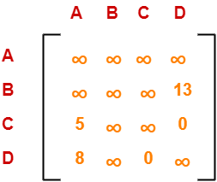

Now,

* We reduce this matrix.
* Then, we find out the cost of node-02.

**Row Reduction-**

* We can not reduce row-1 as all its elements are ∞.
* Reduce all the elements of row-2 by 13.
* There is no need to reduce row-3.
* There is no need to reduce row-4.

Performing this, we obtain the following row-reduced matrix-

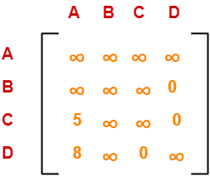

**Column Reduction-**

* Reduce the elements of column-1 by 5.
* We can not reduce column-2 as all its elements are ∞.
* There is no need to reduce column-3.
* There is no need to reduce column-4.

Performing this, we obtain the following column-reduced matrix-

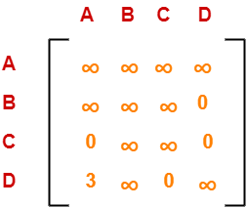

Finally, the matrix is completely reduced.

Now, we calculate the cost of node-2.

Cost(2)

= Cost(1) + Sum of reduction elements + M[A,B]

= 18 + (13 + 5) + 0

= 36

**Choosing To Go To Vertex-C: Node-3 (Path A → C)**

* From the reduced matrix of step-01, M[A,C] = 7
* Set row-A and column-C to ∞
* Set M[C,A] = ∞

Now, resulting cost matrix is-

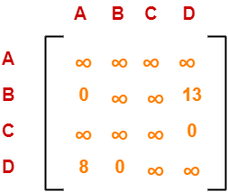

Now,

* We reduce this matrix.
* Then, we find out the cost of node-03.

**Row Reduction-**

* We can not reduce row-1 as all its elements are ∞.
* There is no need to reduce row-2.
* There is no need to reduce row-3.
* There is no need to reduce row-4.

Thus, the matrix is already row-reduced.

**Column Reduction-**

* There is no need to reduce column-1.
* There is no need to reduce column-2.
* We can not reduce column-3 as all its elements are ∞.
* There is no need to reduce column-4.

Thus, the matrix is already column reduced.

Finally, the matrix is completely reduced.

Now, we calculate the cost of node-3.

Cost(3)

= Cost(1) + Sum of reduction elements + M[A,C]

= 18 + 0 + 7

= 25

**Choosing To Go To Vertex-D: Node-4 (Path A → D)**

* From the reduced matrix of step-01, M[A,D] = 3
* Set row-A and column-D to ∞
* Set M[D,A] = ∞

Now, resulting cost matrix is-

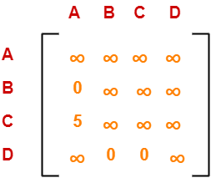

Now,

* We reduce this matrix.
* Then, we find out the cost of node-04.

**Row Reduction-**

* We can not reduce row-1 as all its elements are ∞.
* There is no need to reduce row-2.
* Reduce all the elements of row-3 by 5.
* There is no need to reduce row-4.

Performing this, we obtain the following row-reduced matrix-

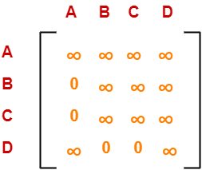

**Column Reduction-**

* There is no need to reduce column-1.
* There is no need to reduce column-2.
* There is no need to reduce column-3.
* We can not reduce column-4 as all its elements are ∞.

Thus, the matrix is already column-reduced.

Finally, the matrix is completely reduced.

Now, we calculate the cost of node-4.

Cost(4)

= Cost(1) + Sum of reduction elements + M[A,D]

= 18 + 5 + 3

= 26

**Thus, we have-**

* Cost(2) = 36 (for Path A → B)
* Cost(3) = 25 (for Path A → C)
* Cost(4) = 26 (for Path A → D)

We choose the node with the lowest cost.

Since cost for node-3 is lowest, so we prefer to visit node-3.

Thus, we choose node-3 i.e. path **A → C**.

**Step-03:**

We explore the vertices B and D from node-3.

We now start from the cost matrix at node-3 which is-



**Cost(3) = 25**

**Choosing To Go To Vertex-B: Node-5 (Path A → C → B)**

* From the reduced matrix of step-02, M[C,B] = ∞
* Set row-C and column-B to ∞
* Set M[B,A] = ∞

Now, resulting cost matrix is-

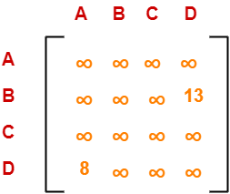

Now,

* We reduce this matrix.
* Then, we find out the cost of node-5.

**Row Reduction-**

* We can not reduce row-1 as all its elements are ∞.
* Reduce all the elements of row-2 by 13.
* We can not reduce row-3 as all its elements are ∞.
* Reduce all the elements of row-4 by 8.

Performing this, we obtain the following row-reduced matrix-

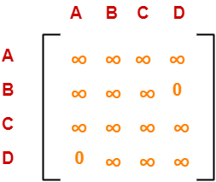

**Column Reduction-**

* There is no need to reduce column-1.
* We can not reduce column-2 as all its elements are ∞.
* We can not reduce column-3 as all its elements are ∞.
* There is no need to reduce column-4.

Thus, the matrix is already column reduced.

Finally, the matrix is completely reduced.

Now, we calculate the cost of node-5.

Cost(5)

= cost(3) + Sum of reduction elements + M[C,B]

= 25 + (13 + 8) + ∞

= ∞

**Choosing To Go To Vertex-D: Node-6 (Path A → C → D)**

* From the reduced matrix of step-02, M[C,D] = ∞
* Set row-C and column-D to ∞
* Set M[D,A] = ∞

Now, resulting cost matrix is-

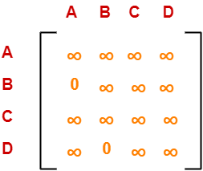

Now,

* We reduce this matrix.
* Then, we find out the cost of node-6.

**Row Reduction-**

* We can not reduce row-1 as all its elements are ∞.
* There is no need to reduce row-2.
* We can not reduce row-3 as all its elements are ∞.
* We can not reduce row-4 as all its elements are ∞.

Thus, the matrix is already row reduced.

**Column Reduction-**

* There is no need to reduce column-1.
* We can not reduce column-2 as all its elements are ∞.
* We can not reduce column-3 as all its elements are ∞.
* We can not reduce column-4 as all its elements are ∞.

Thus, the matrix is already column reduced.

Finally, the matrix is completely reduced.

Now, we calculate the cost of node-6.

Cost(6)

= cost(3) + Sum of reduction elements + M[C,D]

= 25 + 0 + 0

= 25

**Thus, we have-**

* Cost(5) = ∞ (for Path A → C → B)
* Cost(6) = 25 (for Path A → C → D)

We choose the node with the lowest cost.

Since cost for node-6 is lowest, so we prefer to visit node-6.

Thus, we choose node-6 i.e. path **C → D**.

**Step-04:**

We explore vertex B from node-6.

We start with the cost matrix at node-6 which is-



**Cost(6) = 25**

**Choosing To Go To Vertex-B: Node-7 (Path A → C → D → B)**

* From the reduced matrix of step-03, M[D,B] = 0
* Set row-D and column-B to ∞
* Set M[B,A] = ∞

Now, resulting cost matrix is-

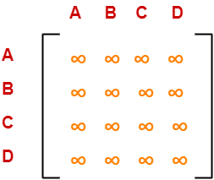

Now,

* We reduce this matrix.
* Then, we find out the cost of node-7.

**Row Reduction-**

* We can not reduce row-1 as all its elements are ∞.
* We can not reduce row-2 as all its elements are ∞.
* We can not reduce row-3 as all its elements are ∞.
* We can not reduce row-4 as all its elements are ∞.

**Column Reduction-**

* We can not reduce column-1 as all its elements are ∞.
* We can not reduce column-2 as all its elements are ∞.
* We can not reduce column-3 as all its elements are ∞.
* We can not reduce column-4 as all its elements are ∞.

Thus, the matrix is already column reduced.

Finally, the matrix is completely reduced.

All the entries have become ∞.

Now, we calculate the cost of node-7.

Cost(7)

= cost(6) + Sum of reduction elements + M[D,B]

= 25 + 0 + 0

= 25

Thus,

* Optimal path is: **A → C → D → B → A**
* Cost of Optimal path = **25 units**